Xamine — Staged Product Documentation
Oct 2, 2026 · @Olumide

1. Overview and staged approach
Xamine is built in two stages: Stage 1 is a lean CBT exam tool with no student database, and Stage 2 grows it into the full school platform.
Xamine ("examine me" with "mine" removed) lets schools run computer-based exams. Schools upload their own questions, generate access PINs, and students take timed exams that are marked automatically.
- Stage 1 — Lean CBT. One school admin role. The school uploads questions, generates PINs, opens the exam, reads and prints the results. Students need no account.
- Stage 2 — Full Xamine. Adds teacher, student and parent accounts, a student database, essay marking, a question bank, PDF results and subscriptions, as in the earlier documentation.
Stage 1 is designed so that nothing built there is thrown away in Stage 2.

2. Stage 1 — Lean CBT (no student database)
Stage 1 lets a school upload questions, generate PINs and run auto-marked exams without storing any student records.
Goal. The simplest working exam tool a school can use in one exam period. It is purely for exams; features are added on top over time.
How access works. The PIN is the student's login. The student enters the PIN, types their name and class, and starts. The name is saved only on that one attempt and appears on the student's result.
In scope
- School account with a single admin role
- Create an exam: title, subject, class label, duration, instructions
- Add objective questions (multiple choice, true/false) by Excel template or manual form
- Bulk-generate single-use PINs for an exam, with a printable list
- Exam status of draft, open or closed; PINs work only while the exam is open
- Timed exam with countdown, server-side timer, answer autosave and auto-submit
- Random question and option order per student
- Instant auto-marking, with the score shown to the student
- Results list per exam for the school, with export
Out of scope until Stage 2
- Student, teacher and parent accounts, and any student database
- Essay, short-answer and fill-in-the-blank questions
- Assignments, save-and-resume work, PDF reports, analytics and billing

3. Stage 2 — Full Xamine
Stage 2 wraps the same exam engine in accounts and roles so Xamine can be sold to many schools as a subscription product.
The workflow follows the earlier documentation. Management creates teacher and student accounts. Teachers upload questions. The system generates a code per student that stays inactive until management opens the access window. Objective questions are graded instantly, essay and theory answers go to the teacher, and results reach management and parents.
Role | What it does in Stage 2
Management / school admin | Create, edit and suspend accounts; bulk import by spreadsheet; organize classes, streams and sessions; open and close access windows; assign teachers; set grading scales; view all attempts and analytics; announcements; billing
Teacher | Create exams, tests and assignments; all question types with images; attempt limits and shuffle; reusable tagged question bank; manual scoring of essays; results for own classes only; duplicate a past exam
Student | Enter code; timed interface with auto-submit; save and resume for assignments; immediate score; past exam history
Parent | View a child's results; download or print as PDF; history across terms; optional SMS or email alerts
Beyond Stage 2, the roadmap holds free-form document parsing, tab-switch detection, a question bank marketplace, offline mode, a mobile app or PWA, plagiarism detection, a school management system integration, and self-serve school onboarding with a super-admin dashboard.

4. Stage comparison
Stage 2 adds identity and roles around the same exam engine; the engine itself does not change.
Area | Stage 1 | Stage 2
Users | School admin only | Management, teacher, student, parent
Student identity | PIN plus typed name, no record kept | Student accounts, bulk import, classes
Access code | Single-use PIN per exam | Code per student, inactive until the access window opens
Exam status | Draft, open, closed | Draft, scheduled, open, closed
Assessment types | Timed exams | Exams, tests and assignments in one model with a type field
Question types | Multiple choice, true/false | Adds fill-in-the-blank, short answer, essay/theory
Question input | Excel template or manual form | Same, plus a reusable tagged question bank
Marking | Auto-marking | Auto-marking plus manual essay scoring by the teacher
Results | Results list and export for the school | Printable PDF, management dashboard, parent view
Billing | None; pilot free | Per-school subscription with tiers
Carried over unchanged: exam creation, question upload, the server-side timer and autosave, auto-marking, and the school-scoped data model.

5. Workflow flowchart
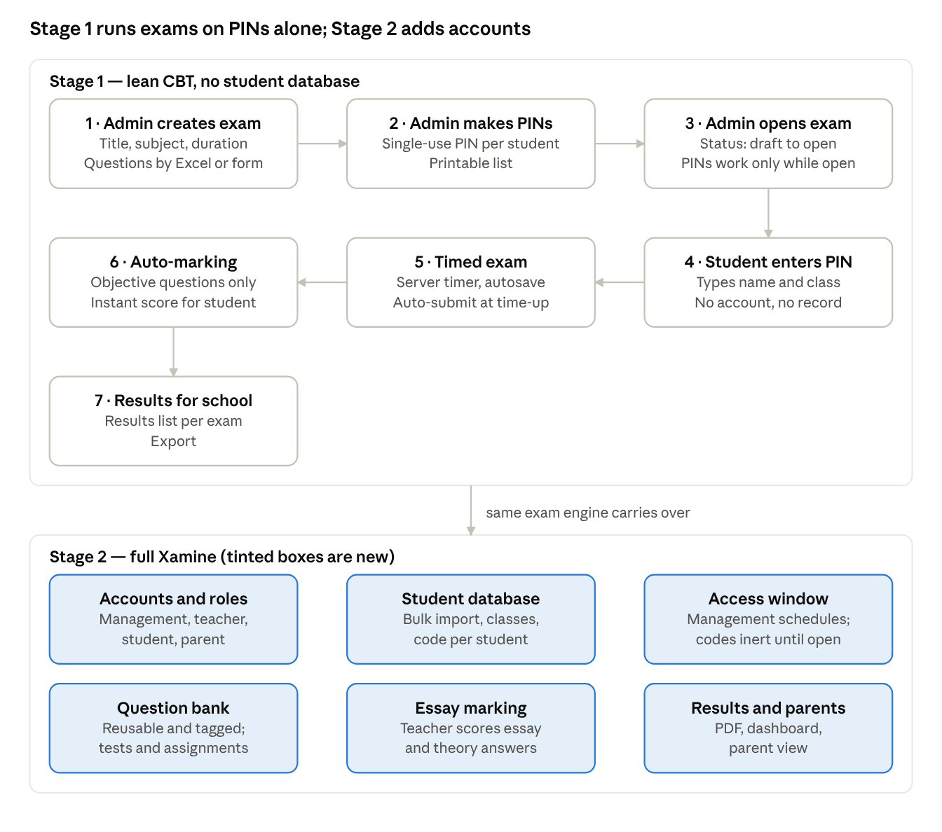
staged workflow · Stage 1 in 7 steps, Stage 2 additions
Stage 1 is one seven-step path that needs no student records; Stage 2 wraps six additions around the same exam engine.

6. Technical architecture and data model
Both stages share one stack and one tenant model, so Stage 2 extends the Stage 1 tables instead of replacing them.
Stack. Next.js frontend with API routes, a Postgres database, and server-side auto-marking. PDF generation arrives in Stage 2 using free libraries.
Design rules from day one
- Every record carries a school_id, so a second school needs no rework.
- The exam timer runs on the server: the start time is stored and late submissions are rejected, so a refresh never resets the clock.
- Answers autosave as the student works, so a power or network drop loses nothing.
- A PIN is valid only while its exam is open.
Entity | Stage 1 | Stage 2 change
schools | Tenant boundary | Adds subscription
admins | School admin logins, the only accounts | Become users with roles: management, teacher, student, parent
exams | Title, subject, class label, duration, status | Become assessments with a type field and an access window
questions | Linked to an exam; type, options, correct answer | Adds images, more question types, question bank tags
pins | One per student per exam, with a used flag | Become access_codes tied to a student account
attempts | Typed name, answers, score, timestamps | Linked to a student account
results | Not needed; the attempt holds the score | Finalized, printable score record for the parent view
classes | Not used | Classes, streams and sessions

7. Build order and milestones
Build Stage 1 end to end first, and put it in front of a pilot school before starting Stage 2.
Stage 1
- School admin sign-in and school record
- Create an exam and add questions: manual form, then Excel template
- Generate PINs and control exam status (draft, open, closed)
- Student flow: enter PIN and name, take the timed exam, autosave, auto-submit
- Auto-marking and instant score
- School results view and export
- Pilot with one or two schools
Stage 2, following the earlier build order
- Management: teacher and student accounts, core CRUD
- Teacher: question builder with all question types, per-student codes
- Student flow using codes tied to accounts
- Management dashboard: attempts, scores, filters by class and exam
- Parent view: read-only result lookup
- PDF export of results

8. Costs and monetization
The earlier estimates carry over; Stage 1 avoids the largest recurring cost, SMS, because the school prints or hands out the PINs.
- Build time: a solo MVP of the full product was estimated at 6–10 weeks of focused work. Stage 1 is a subset and has not been estimated separately.
- Hiring help: freelance Next.js/Node developers in Nigeria typically run ₦150k–400k per month.
- Running costs: hosting about $0–20 per month early, database about $10–25 per month as it grows. SMS (usage-based) and PDF generation (free libraries) apply from Stage 2.
- Pricing options: per-school subscription (₦15k–50k per term), per-student (₦100–300 per term), tiered plans, a one-time setup fee, pay-per-exam-cycle, and add-ons.
Recommended start: pilot Stage 1 free with one or two schools before pricing seriously. Pay-per-exam-cycle is the easiest first sale; per-school tiers fit Stage 2.

9. Open decisions for Stage 1
Four choices left to settle before the Stage 1 build starts.
- ☐ Student identity: confirmed. Students type their name and class at login, with no pre-loaded student list, and the name appears on their result.
- ☐ PIN and disconnects: can a student resume with the same PIN until time runs out? Proposed: yes, one attempt only.
- ☐ School setup: do schools sign up themselves, or do you create each pilot school's account?
- ☐ Results output: export only, or also a printable results page?
- ☐ Question upload: Excel template first, or the manual form first?

